**anchRoll No: 112**

**Name: RUTIK VASANT KHARCHE**

**Practical No: 8**

**Practical Name: Use git merge to merge you changes to the primary branch.**

comp@com135 MINGW64 ~/KBCNMU (branch2)

$ git merge main branch2

Already up to date.

comp@com135 MINGW64 ~/KBCNMU (branch2)

$ git branch --list

* branch2

main

comp@com135 MINGW64 ~/KBCNMU (branch2)

$ git checkout main

Switched to branch 'main'

A rj.txt

Your branch is up to date with 'origin/main'.

comp@com135 MINGW64 ~/KBCNMU (main)

$ git pull https://github.com/Shitu18/KBCNMU.git

remote: Enumerating objects: 1, done.

remote: Counting objects: 100% (1/1), done.

remote: Total 1 (delta 0), reused 0 (delta 0), pack-reused 0

Unpacking objects: 100% (1/1), 631 bytes | 17.00 KiB/s, done.

From https://github.com/Shitu18/KBCNMU

* branch HEAD -> FETCH_HEAD

Updating 1597074..11335a5

Fast-forward

srp.txt | 0

1 file changed, 0 insertions(+), 0 deletions(-)

create mode 100644 srp.txt

**Before Merge to local repository:**

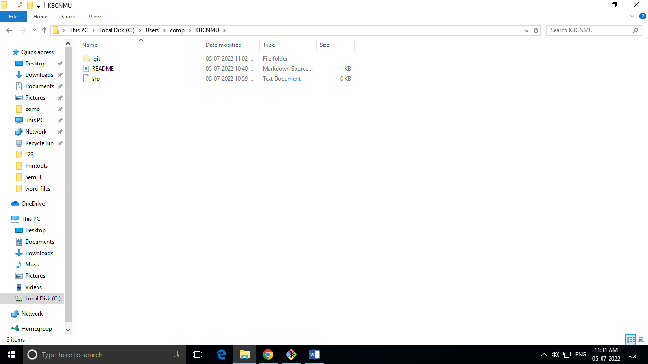

**After Merge to local repository:**

